# **The Battle of Neighborhoods**

# **Opening Turkish Restaurants in Bucharest, Romania**

# **IBM Data Science Professional Certificate**

# **Applied Data Science Capstone Assignment**

# **Abraham Liu**

# 

# 

# **The Battle of Neighborhoods**

## **Opening Turkish Restaurants in Bucharest, Romania**

### **Introduction/Business Problem**

#### **Background Information**

Bucharest is the capital and largest city in the country of Romania. It is also considered the cultural, industrial, and financial center of Romania. Bucharest is located at the following coordinates: 44.4268° N, 26.1025° E. With an estimated population of over 2 million people, it is divided up into 6 neighborhoods and are listed below:

* Sector 1
* Sector 2
* Sector 3
* Sector 4
* Sector 5
* Sector 6

#### **Problem**

In this project, because Bucharest is such a cultural city, I want to investigate if there are any locations that should open Turkish restaurants and whether or not there is a need for it.

#### **Interest**

Anyone who wants to open a new venue in any geographic location may be interested in this project by modifying search criteria.

### **Data**

#### **Data Sources**

To consider the problem we can list the following data sources, noted below:

* I get neighborhood data of Bucharest from Wikipedia
* I use python geocoder library to get geographical coordinates of neighborhoods
* I use the Foursquare API venues explore method to get the venues of given neighborhoods of Sacramento
* I use the Foursquare API venues method to get ranks and likes of restaurants by given venue id

#### **Feature Selection and Data Usage**

I will use neighborhood location values to analyze the Bucharest geographical structure. I will use the folium library of python to draw maps by using given latitude and longitudes of neighborhoods. Selected features will be as below.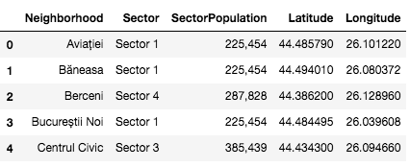

I will use populations of neighborhoods who have big populations who may need a new restaurant.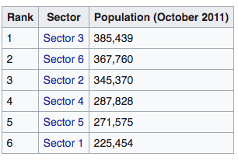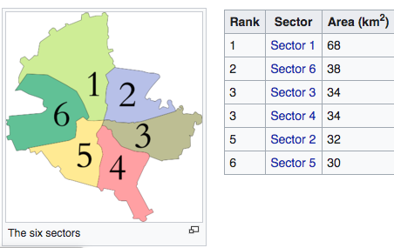

I will also classify neighborhoods by using venues distribution and counts. In this way, I will find similarities of counties which will help me choose locations for opening a new restaurant. Similar structured counties may handle the same type of venues.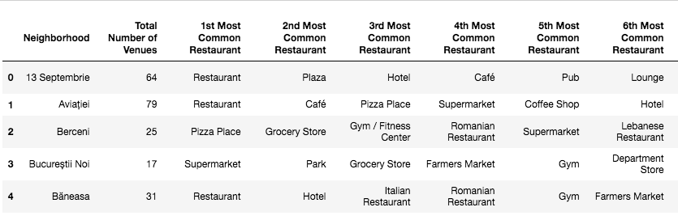

I will use the venue list category to find the distribution of restaurants and Turkish restaurants in neighborhoods.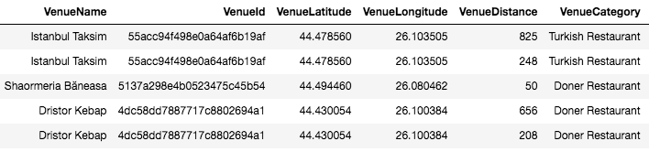

I will also use ratings and likes of restaurants in the area. It may help me to find locations with bad rating restaurants which may need a new restaurant.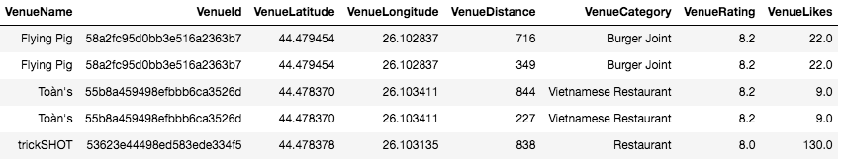

### **Methodology**

* I used the GitHub repository for code versioning.
* The Bucharest data is available with the neighborhood name in Wikipedia. Location information (latitude and longitude) of neighborhoods were extracted using the geocoder library.
* I took neighborhood data from Wikipedia, putting blue dots on a map of Bucharest to see centers of neighborhoods. There are a total of 40 neighborhoods in Bucharest.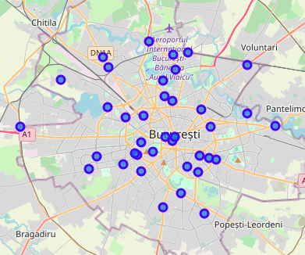
* I also extracted sector names, neighborhoods belonging to which sector, and sector population. There are a total of 6 sectors in Bucharest. To make information more condensed, I merged Sectors and the data of which neighborhoods belong to what sector.

By using Foursquare API, I was able to get venue information that was 1km around the center of each neighborhood with a limit of 100 venues. I also merged this venue information with my neighborhood data. Information of merged data is listed below

* There are 229 unique venue categories in Bucharest and the top 10 venue counts are as below.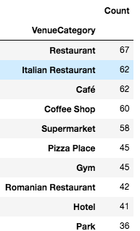
* I filtered all restaurants and Turkish restaurants. We can see from a histogram of restaurants that 20 neighborhoods do not have any Turkish restaurants.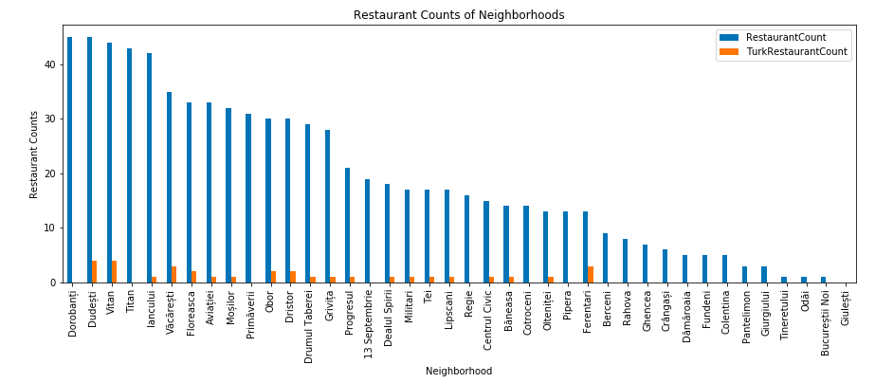
* I used Foursquare to extract restaurant ratings by using venue id and merged ratings with venue data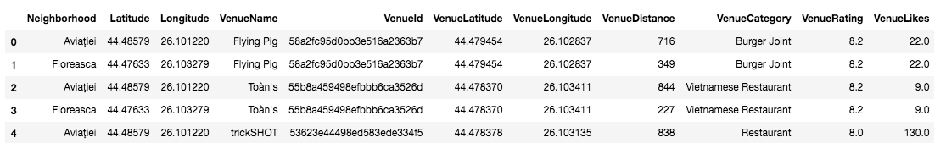
* I drew a heatmap for counts of restaurants by using the Folium library. On the heatmap, I drew 4 circles indicating distances of 2km, 4km, 6km, and 10km from the center of Bucharest
* With red markers, I superimposed Turkish restaurants on the first heatmap.
* With blue markers, I superimposed Turkish restaurants with a rating less than 7 on the first heatmap.

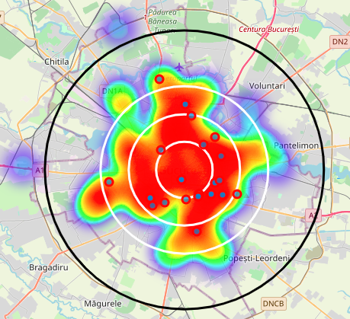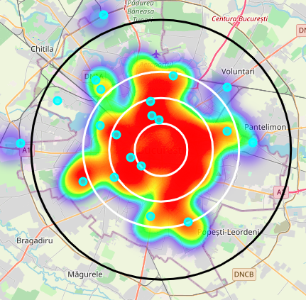

* With cyan markers, I superimposed neighborhoods with no Turkish restaurants on a second heatmap.
* I used Agglomerative Clustering to cluster neighborhoods according to the count of venue categories in each neighborhood. According to the graph, it allowed me to decide to divide the neighborhoods into 6 different clusters (cut off distance at 20, the horizontal black line).

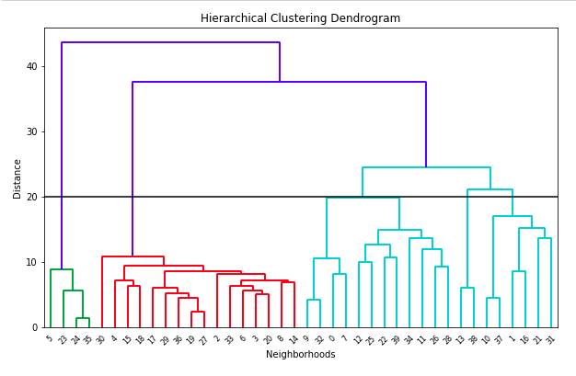

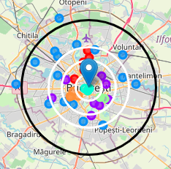

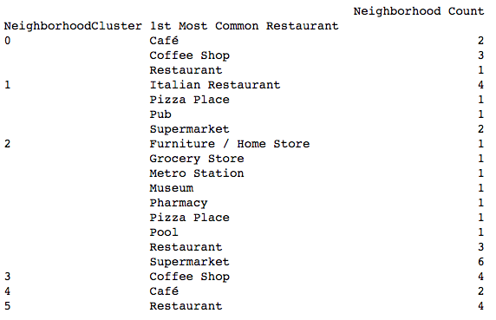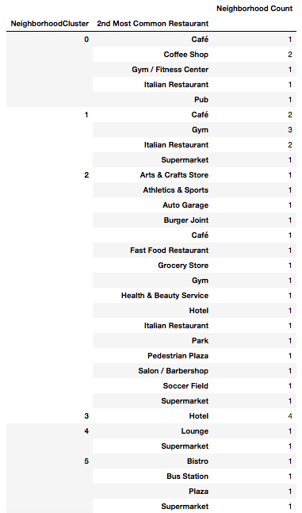

We can see cluster categories as below

Cluster 0 (Red): Café, Italian Restaurant, Pub

Cluster 1 (Purple): Café, Pub

Cluster 2 (Blue): Grocery Store, Plaza

Cluster 3 (Cyan): Café, Hotel

Cluster 4 (Green): Café, Lounge

Cluster 5 (Orange): Plaza, Bistro, Supermarket

### **Results**

I investigated that the total Turksich restaurant count in Bucharest is 4.25%

* Total number of restaurants: 494
* Total number of Turkish restaurants: 21

From the bar chart, we can see:

* Dorobanți is the neighborhood with the most restaurants.
* Dorobanți has many restaurants, but no Turkish restaurants.
* Bucureștii Noi, Giulești, and Odăi are the neighborhoods with the least amount of restaurants.
* 20 neighborhoods do not have any Turkish restaurants. We can probably choose one of these neighborhoods to open a Turkish restaurant in.

From heat maps, we can draws conclusions to the following:

* There are too many restaurants 4km from the center of Bucharest.
* There are enough restaurants between 4-6km from the center of Bucharest.
* After 6km from the center, there are not many restaurants.
* All Turkish restaurants are about 2-4km from the center of Bucharest with them in the South, North, and East parts of Bucharest.
* There are no Turkish restaurants in West and North West Bucharest.
* Some Turkish restaurants do not have good ratings. That suggests that people do not prefer Turkish restaurants and new restaurants should not be opened near them.

### **Discussion**

* Cluster 2 suffers from a lack of restaurants. We can think about adding a Turkish restaurant in Cluster 2, in particular on the West side of Bucharest.
* Cluster 0 has a preference for Italian restaurants, suggesting that Turkish restaurants would not be successful in Cluster 0, with the exception of one location, which might work.
* Cluster 1, 2, and 3 are full of restaurants, as shown with the heatmap.

### **Conclusion**

### **Screen%20Shot%202020-07-15%20at%205.04.57%20PM.pngScreen%20Shot%202020-07-15%20at%205.07.39%20PM.png**

### **Screen%20Shot%202020-07-15%20at%205.07.48%20PM.pngScreen%20Shot%202020-07-15%20at%205.05.04%20PM.png**

I have chosen 4 potential locations for opening a Turkish restaurant. Below are neighborhood locations as well as the reason as to why I think Turkish restaurants would be successful in that neighborhood.

* Neighborhood: Regie, Cluster 1, Sector 6, Population: 367760  
  I chose Regie, since the west part of Bucharest has no Turkish restaurants and Regie is also very close to the center. Regies is also in a Cluster that seems to be open to a variety of kinds of restaurants.
* Neighborhood: Bucureștii Noi , Cluster 2, Sector 1 , Population : 225454  
  I chose Bucureștii Noi because, like Regie, it is in the west part of Bucharest which has no Turkish restaurants. Considering the lack of restaurants 6km from the center, this is a good option to open one in this area.
* Neighborhood: Crângași, Cluster 2, Sector 6 , Population : 367760  
  I chose Crângași because like Bucureștii Noi and Regie, it is in the west part of Bucharest which has no Turkish restaurants. I chose this Sector specifically because of the large population. With a large population, it can support multiple restaurants and a diverse choice of restaurants is a great business practice.
* Neighborhood: Tineretului, Cluster 2 Sector 4 Population: 287828  
  I chose Tineretului because it is very isolated and it has no Turkish restaurants. Because of its isolated nature, this neighborhood does not have many restaurants and it should open a Turkish restaurant.